# EEE3088F 2023

# Concept Proposal

## Enviro sensing HAT Concept

The HAT is designed to function as a device that detects temperature. The proposed device is compact, passive and can convert thermal energy into an electrical signal output. It has practical applications for various groups of people, such as shipping security companies, farmers and civilians.

The HAT has several potential applications, including monitoring the temperature in greenhouses, detecting abnormal temperature changes in data centres, and tracking battery temperature on smartphones.

The HAT is designed to be easy to install, with a simple attachment mechanism that allows it to be secured to different surfaces, such as the roof of a greenhouse or the surface of a computer server. The device has different power input supply connections, allowing it to be directly connected to a power source or powered wirelessly.

Overall, the proposed HAT design has the potential to offer a cost-effective and practical solution for temperature monitoring in various settings, providing benefits such as energy savings, early fault detection, and improved battery care/life.

## 

## Requirements

.

User role/Scenario1

In data centres, the HAT can detect abnormal temperature changes, allowing for early detection of potential hardware failures and preventing costly downtime.

* R1.1: The HAT must be able to withstand extreme sunlight.
* R1.2: The HAT must signal an alert when temperatures are abnormal.
* R1.3: The circuit must always be ensured it is ON.

User role/Scenario 2

In the greenhouse, the HAT can help farmers maintain a suitable temperature for plant growth, reducing energy consumption and increasing crop yields.

* R2.1: The HAT will have a desired threshold temperature at which can be captured by the circuit easily.
* R2.2: Able to withstand utmost humidity.
* R2.3: Values below and above the desired range must trigger the internal diodes/lights to turn ON and OFF.

User role/Scenario 3

In smartphone batteries, the HAT can be used to monitor the temperature of the battery, allowing protection and ensuring long life span of the phone by monitoring and informing when the phone battery is overheated.

* R3.1: The temperature sensitivity of the enclosed package is set as default.
* R3.2: Overheat of the battery, the HAT must signal an alert to switch OFF the phone in about 2 minutes.
* R3.3: The temperature sensor must have a quick response to temperature alterations.

## Project Subsystems Block Diagram

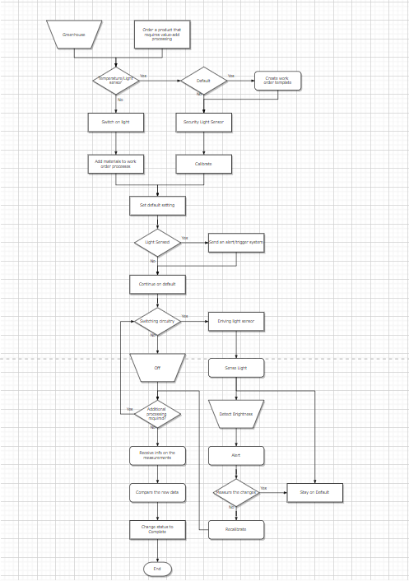

Figure 1: Conceptual Block Diagram for Subsystems[Authors Own Diagram]

## 

## Link to Team Git Repo

<https://github.com/asisiphoSpan/EEE3088F-project-team-2/tree/main/CONCEPT%20PROPOSAL>